Data Structures Lab
Assignment 01


By
Mamoona Anwar
FA25-BCS-020

Submitted to,
Mr. Bilal Bukhari
October 04, 2026

Department of Computer Science
COMSATS University Islamabad, Attock Campus
Singly Linked List
Task 01: Display singly linked list in reverse order
#include <iostream> // Include input-output library
using namespace std; // Use standard namespace

struct Node { // Define node structure
int data; // Store integer data
Node* next; // Pointer to next node
};

Node* createNode(int value) { // Function to create a new node
Node* n = new Node; // Allocate memory for node
n->data = value; // Set data value
n->next = nullptr; // Set next pointer to null
return n; // Return new node
}

void insertEnd(Node*& head, int value) { // Insert node at end
Node* n = createNode(value); // Create new node
if (head == nullptr) { // If list is empty
head = n; // Make new node the head
return; // Exit function
}
Node* temp = head; // Start from head
while (temp->next != nullptr) { // Traverse to last node
temp = temp->next; // Move to next node
}
temp->next = n; // Link last node to new node
}

void printReverse(Node* head) { // Print list in reverse order
if (head == nullptr) return; // Base case: empty node
printReverse(head->next); // Recursively go to end
cout << head->data << " "; // Print while returning back
}

void printForward(Node* head) { // Print list in normal order
Node* temp = head; // Start from head
while (temp != nullptr) { // Until end of list
cout << temp->data << " "; // Print current data
temp = temp->next; // Move forward
}
cout << endl; // Print newline
}

int main() { // Main function
Node* head = nullptr; // Initially empty list
insertEnd(head, 10); // Insert 10
insertEnd(head, 20); // Insert 20
insertEnd(head, 30); // Insert 30
insertEnd(head, 40); // Insert 40
cout << "Forward: "; // Print label
printForward(head); // Print normal list
cout << "Reverse: "; // Print label
printReverse(head); // Print reversed order
cout << endl; // Print newline
return 0; // End program
}
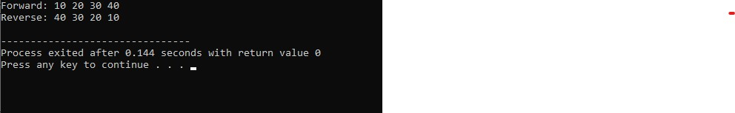
Output:

Task 02: Reverse the singly Linked list itself
#include <iostream> // Include input-output library
using namespace std; // Use standard namespace

struct Node { // Define node structure
int data; // Store data
Node* next; // Pointer to next node
};

Node* createNode(int value) { // Create new node
Node* n = new Node; // Allocate memory
n->data = value; // Set data
n->next = nullptr; // Set next null
return n; // Return node
}

void insertEnd(Node*& head, int value) { // Insert at end
Node* n = createNode(value); // Create node
if (head == nullptr) { // If empty list
head = n; // Set head
return; // Exit
}
Node* temp = head; // Start from head
while (temp->next != nullptr) { // Go to last node
temp = temp->next; // Move forward
}
temp->next = n; // Link last node
}

Node* reverseList(Node* head) { // Reverse linked list
Node* prev = nullptr; // Previous pointer starts null
Node* curr = head; // Current pointer starts head
Node* next = nullptr; // Next pointer for saving
while (curr != nullptr) { // Traverse all nodes
next = curr->next; // Save next node
curr->next = prev; // Reverse current link
prev = curr; // Move prev forward
curr = next; // Move curr forward
}
return prev; // New head is prev
}

void printList(Node* head) { // Print linked list
Node* temp = head; // Start from head
while (temp != nullptr) { // Until end
cout << temp->data << " "; // Print data
temp = temp->next; // Move next
}
cout << endl; // Newline
}

int main() { // Main function
Node* head = nullptr; // Empty list
insertEnd(head, 1); // Insert 1
insertEnd(head, 2); // Insert 2
insertEnd(head, 3); // Insert 3
insertEnd(head, 4); // Insert 4
cout << "Original: "; // Label
printList(head); // Print original
head = reverseList(head); // Reverse list
cout << "Reversed: "; // Label
printList(head); // Print reversed
return 0; // End program
}

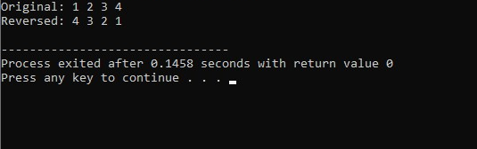
Output:

Task 03: Remove all duplicates contacts from singly linked list
#include <iostream> // Include input-output library
using namespace std; // Use standard namespace

struct Node { // Node structure
int data; // Contact ID
Node* next; // Next pointer
};

Node* createNode(int value) { // Create node
Node* n = new Node; // Allocate memory
n->data = value; // Set data
n->next = nullptr; // Set next null
return n; // Return node
}

void insertEnd(Node*& head, int value) { // Insert at end
Node* n = createNode(value); // Create node
if (head == nullptr) { // If empty
head = n; // Set head
return; // Exit
}
Node* temp = head; // Start from head
while (temp->next != nullptr) { // Go to last
temp = temp->next; // Move forward
}
temp->next = n; // Link last node
}

void removeDuplicates(Node* head) { // Remove duplicate values
Node* current = head; // Start from head
while (current != nullptr && current->next != nullptr) { // Traverse each node
Node* runner = current; // Runner starts from current
while (runner->next != nullptr) { // Check all later nodes
if (runner->next->data == current->data) { // If duplicate found
Node* dup = runner->next; // Save duplicate node
runner->next = runner->next->next; // Skip duplicate
delete dup; // Delete duplicate node
} else {
runner = runner->next; // Move runner forward
}
}
current = current->next; // Move current forward
}
}

void printList(Node* head) { // Print list
Node* temp = head; // Start from head
while (temp != nullptr) { // Until end
cout << temp->data << " "; // Print data
temp = temp->next; // Move next
}
cout << endl; // Newline
}

int main() { // Main function
Node* head = nullptr; // Empty list
insertEnd(head, 10); // Insert 10
insertEnd(head, 20); // Insert 20
insertEnd(head, 10); // Insert duplicate 10
insertEnd(head, 30); // Insert 30
insertEnd(head, 20); // Insert duplicate 20
cout << "Original: "; // Label
printList(head); // Print original
removeDuplicates(head); // Remove duplicates
cout << "After removing duplicates: "; // Label
printList(head); // Print final list
return 0; // End program }
Output:
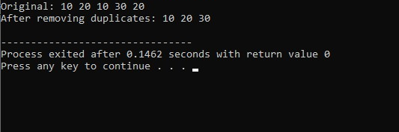

Task 04: Detect loop in singly linked list
#include <iostream> // Include input-output library
using namespace std; // Use standard namespace

struct Node { // Node structure
int data; // Store data
Node* next; // Next pointer
};

Node* createNode(int value) { // Create node
Node* n = new Node; // Allocate memory
n->data = value; // Set data
n->next = nullptr; // Set next null
return n; // Return node
}

bool detectLoop(Node* head) { // Detect loop using Floyd cycle
Node* slow = head; // Slow pointer starts head
Node* fast = head; // Fast pointer starts head
while (fast != nullptr && fast->next != nullptr) { // While fast can move
slow = slow->next; // Move slow by one
fast = fast->next->next; // Move fast by two
if (slow == fast) { // If pointers meet
return true; // Loop exists
}
}
return false; // No loop found
}

int main() { // Main function
Node* head = createNode(1); // Create first node
head->next = createNode(2); // Add second node
head->next->next = createNode(3); // Add third node
head->next->next->next = createNode(4); // Add fourth node
head->next->next->next->next = head->next; // Create loop to node 2
if (detectLoop(head)) { // Check loop
cout << "Loop detected" << endl; // Print if loop
} else {
cout << "No loop" << endl; // Print if no loop
}
return 0; // End program }
Output:
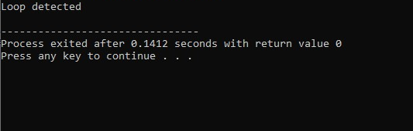

Task 05: Find middle friend, left middle if even
#include <iostream> // Include input-output library
using namespace std; // Use standard namespace

struct Node { // Node structure
int data; // Friend ID
Node* next; // Next pointer
};

Node* createNode(int value) { // Create node
Node* n = new Node; // Allocate memory
n->data = value; // Set data
n->next = nullptr; // Set next null
return n; // Return node
}

void insertEnd(Node*& head, int value) { // Insert at end
Node* n = createNode(value); // Create node
if (head == nullptr) { // If empty
head = n; // Set head
return; // Exit
}
Node* temp = head; // Start from head
while (temp->next != nullptr) { // Go to last
temp = temp->next; // Move forward
}
temp->next = n; // Link last node
}

Node* findLeftMiddle(Node* head) { // Find left middle node
if (head == nullptr) return nullptr; // Empty list
Node* slow = head; // Slow pointer
Node* fast = head; // Fast pointer
while (fast->next != nullptr && fast->next->next != nullptr) { // For left middle
slow = slow->next; // Move slow by one
fast = fast->next->next; // Move fast by two
}
return slow; // Return middle node
}

int main() { // Main function
Node* head = nullptr; // Empty list
insertEnd(head, 1); // Insert 1
insertEnd(head, 2); // Insert 2
insertEnd(head, 3); // Insert 3
insertEnd(head, 4); // Insert 4
Node* middle = findLeftMiddle(head); // Find middle
if (middle != nullptr) { // If list not empty
cout << "Left middle: " << middle->data << endl; // Print middle
}
return 0; // End program
}
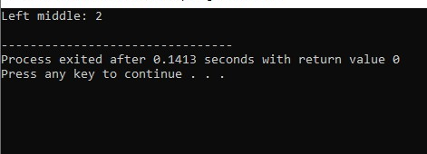
Output:

Task 06: Divide singly linked list into even-priced and odd-priced lines
#include <iostream> // Include input-output library
using namespace std; // Use standard namespace

struct Node { // Node structure
int data; // Fruit price
Node* next; // Next pointer
};

Node* createNode(int value) { // Create node
Node* n = new Node; // Allocate memory
n->data = value; // Set data
n->next = nullptr; // Set next null
return n; // Return node
}

void insertEnd(Node*& head, int value) { // Insert at end
Node* n = createNode(value); // Create node
if (head == nullptr) { // If empty
head = n; // Set head
return; // Exit
}
Node* temp = head; // Start from head
while (temp->next != nullptr) { // Go to last
temp = temp->next; // Move forward
}
temp->next = n; // Link last node
}

void splitEvenOdd(Node* head, Node*& evenHead, Node*& oddHead) { // Split list
evenHead = nullptr; // Even list head
oddHead = nullptr; // Odd list head
Node* evenTail = nullptr; // Even list tail
Node* oddTail = nullptr; // Odd list tail
Node* curr = head; // Start from head
while (curr != nullptr) { // Traverse original list
Node* nextNode = curr->next; // Save next node
curr->next = nullptr; // Detach current node
if (curr->data % 2 == 0) { // If price is even
if (evenHead == nullptr) { // First even node
evenHead = curr; // Set even head
evenTail = curr; // Set even tail
} else {
evenTail->next = curr; // Link to even list
evenTail = curr; // Update even tail
}
} else { // If price is odd
if (oddHead == nullptr) { // First odd node
oddHead = curr; // Set odd head
oddTail = curr; // Set odd tail
} else {
oddTail->next = curr; // Link to odd list
oddTail = curr; // Update odd tail
}
}
curr = nextNode; // Move to next node
}
}

void printList(Node* head) { // Print list
Node* temp = head; // Start from head
while (temp != nullptr) { // Until end
cout << temp->data << " "; // Print data
temp = temp->next; // Move next
}
cout << endl; // Newline
}

int main() { // Main function
Node* head = nullptr; // Empty list
insertEnd(head, 10); // Insert even
insertEnd(head, 15); // Insert odd
insertEnd(head, 22); // Insert even
insertEnd(head, 7); // Insert odd
insertEnd(head, 8); // Insert even
Node* evenHead = nullptr; // Even list head
Node* oddHead = nullptr; // Odd list head
splitEvenOdd(head, evenHead, oddHead); // Split list
cout << "Even prices: "; // Label
printList(evenHead); // Print even list
cout << "Odd prices: "; // Label
printList(oddHead); // Print odd list
return 0; // End program
}
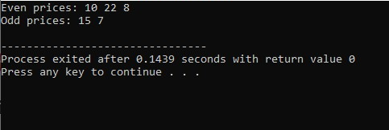
Output:

Task 07: Reverse first half and second half separately
#include <iostream> // Include input-output library
using namespace std; // Use standard namespace

struct Node { // Node structure
int data; // Store data
Node* next; // Next pointer
};

Node* createNode(int value) { // Create node
Node* n = new Node; // Allocate memory
n->data = value; // Set data
n->next = nullptr; // Set next null
return n; // Return node
}

void insertEnd(Node*& head, int value) { // Insert at end
Node* n = createNode(value); // Create node
if (head == nullptr) { // If empty
head = n; // Set head
return; // Exit
}
Node* temp = head; // Start from head
while (temp->next != nullptr) { // Go to last
temp = temp->next; // Move forward
}
temp->next = n; // Link last node
}

Node* reverseNodes(Node* head) { // Reverse a list
Node* prev = nullptr; // Previous pointer
Node* curr = head; // Current pointer
Node* next = nullptr; // Next pointer
while (curr != nullptr) { // Traverse list
next = curr->next; // Save next
curr->next = prev; // Reverse link
prev = curr; // Move prev
curr = next; // Move curr
}
return prev; // Return new head
}

Node* reverseHalves(Node* head) { // Reverse both halves
if (head == nullptr || head->next == nullptr) return head; // If 0 or 1 node
int n = 0; // Count nodes
Node* temp = head; // Start from head
while (temp != nullptr) { // Count all nodes
n++; // Increase count
temp = temp->next; // Move next
}
int firstCount = n / 2; // First half size
Node* firstHead = head; // First half head
Node* firstTail = head; // First half tail
for (int i = 1; i < firstCount; i++) { // Find first half tail
firstTail = firstTail->next; // Move forward
}
Node* secondHead = firstTail->next; // Second half head
firstTail->next = nullptr; // Split list
Node* newFirstHead = reverseNodes(firstHead); // Reverse first half
Node* newSecondHead = reverseNodes(secondHead); // Reverse second half
firstHead->next = newSecondHead; // Connect first half tail to second half
return newFirstHead; // Return new head
}

void printList(Node* head) { // Print list
Node* temp = head; // Start from head
while (temp != nullptr) { // Until end
cout << temp->data << " "; // Print data
temp = temp->next; // Move next
}
cout << endl; // Newline
}

int main() { // Main function
Node* head = nullptr; // Empty list
for (int i = 1; i <= 8; i++) { // Insert 1 to 8
insertEnd(head, i); // Insert current number
}
cout << "Original: "; // Label
printList(head); // Print original
head = reverseHalves(head); // Reverse halves
cout << "After reversing halves: "; // Label
printList(head); // Print result
return 0; // End program
}
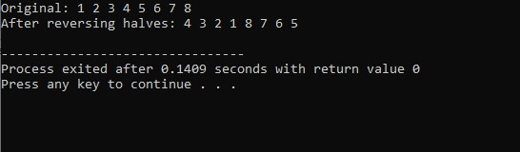
Output:

Task 08: Remove duplicate stamps from singly linked list
#include <iostream> // Include input-output library
using namespace std; // Use standard namespace

struct Node { // Node structure
int data; // Stamp design ID
Node* next; // Next pointer
};

Node* createNode(int value) { // Create node
Node* n = new Node; // Allocate memory
n->data = value; // Set data
n->next = nullptr; // Set next null
return n; // Return node
}

void insertEnd(Node*& head, int value) { // Insert at end
Node* n = createNode(value); // Create node
if (head == nullptr) { // If empty
head = n; // Set head
return; // Exit
}
Node* temp = head; // Start from head
while (temp->next != nullptr) { // Go to last
temp = temp->next; // Move forward
}
temp->next = n; // Link last node
}

void removeDuplicates(Node* head) { // Remove duplicate stamps
Node* current = head; // Start from head
while (current != nullptr && current->next != nullptr) { // For each node
Node* runner = current; // Runner starts at current
while (runner->next != nullptr) { // Check later nodes
if (runner->next->data == current->data) { // If duplicate
Node* dup = runner->next; // Save duplicate
runner->next = runner->next->next; // Skip duplicate
delete dup; // Delete duplicate
} else {
runner = runner->next; // Move runner
}
}
current = current->next; // Move current
}
}

void printList(Node* head) { // Print list
Node* temp = head; // Start from head
while (temp != nullptr) { // Until end
cout << temp->data << " "; // Print data
temp = temp->next; // Move next
}
cout << endl; // Newline
}

int main() { // Main function
Node* head = nullptr; // Empty list
insertEnd(head, 101); // Insert stamp
insertEnd(head, 102); // Insert stamp
insertEnd(head, 101); // Insert duplicate
insertEnd(head, 103); // Insert stamp
insertEnd(head, 102); // Insert duplicate
cout << "Original stamps: "; // Label
printList(head); // Print original
removeDuplicates(head); // Remove duplicates
cout << "Unique stamps: "; // Label
printList(head); // Print final
return 0; // End program
}
Output:
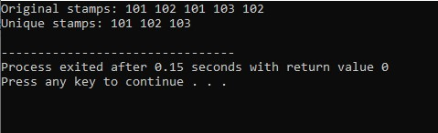

Task 09: Delete all instances of a given book identifier
#include <iostream> // Include input-output library
using namespace std; // Use standard namespace

struct Node { // Node structure
int data; // Book identifier
Node* next; // Next pointer
};

Node* createNode(int value) { // Create node
Node* n = new Node; // Allocate memory
n->data = value; // Set data
n->next = nullptr; // Set next null
return n; // Return node
}

void insertEnd(Node*& head, int value) { // Insert at end
Node* n = createNode(value); // Create node
if (head == nullptr) { // If empty
head = n; // Set head
return; // Exit
}
Node* temp = head; // Start from head
while (temp->next != nullptr) { // Go to last
temp = temp->next; // Move forward
}
temp->next = n; // Link last node
}

Node* deleteAll(Node* head, int key) { // Delete all matching nodes
while (head != nullptr && head->data == key) { // If head matches
Node* temp = head; // Save head
head = head->next; // Move head forward
delete temp; // Delete old head
}
Node* current = head; // Start from new head
while (current != nullptr && current->next != nullptr) { // Traverse
if (current->next->data == key) { // If next matches
Node* temp = current->next; // Save matching node
current->next = current->next->next; // Skip it
delete temp; // Delete matching node
} else {
current = current->next; // Move current forward
}
}
return head; // Return updated head
}

void printList(Node* head) { // Print list
Node* temp = head; // Start from head
while (temp != nullptr) { // Until end
cout << temp->data << " "; // Print data
temp = temp->next; // Move next
}
cout << endl; // Newline
}

int main() { // Main function
Node* head = nullptr; // Empty list
insertEnd(head, 3); // Insert 3 at beginning
insertEnd(head, 5); // Insert 5
insertEnd(head, 3); // Insert 3 in middle
insertEnd(head, 7); // Insert 7
insertEnd(head, 3); // Insert 3 at end
cout << "Original: "; // Label
printList(head); // Print original
head = deleteAll(head, 3); // Delete all 3s
cout << "After deleting 3: "; // Label
printList(head); // Print final
return 0; // End program
}
Output:
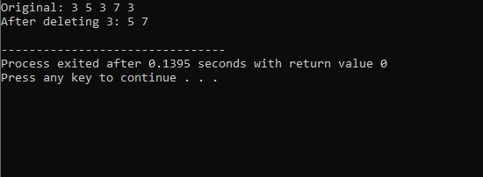

Task 10: Swap every two consecutive nodes in singly linked list
#include <iostream> // Include input-output library
using namespace std; // Use standard namespace

struct Node { // Node structure
int data; // Task ID
Node* next; // Next pointer
};

Node* createNode(int value) { // Create node
Node* n = new Node; // Allocate memory
n->data = value; // Set data
n->next = nullptr; // Set next null
return n; // Return node
}

void insertEnd(Node*& head, int value) { // Insert at end
Node* n = createNode(value); // Create node
if (head == nullptr) { // If empty
head = n; // Set head
return; // Exit
}
Node* temp = head; // Start from head
while (temp->next != nullptr) { // Go to last
temp = temp->next; // Move forward
}
temp->next = n; // Link last node
}

Node* swapPairs(Node* head) { // Swap every two nodes
if (head == nullptr || head->next == nullptr) return head; // If less than 2 nodes
Node* newHead = head->next; // Second node becomes new head
Node* prev = nullptr; // Previous pair tail
Node* curr = head; // Current node
while (curr != nullptr && curr->next != nullptr) { // While pair exists
Node* first = curr; // First node of pair
Node* second = curr->next; // Second node of pair
Node* nextPair = second->next; // Next pair start
second->next = first; // Second points to first
first->next = nextPair; // First points to next pair
if (prev != nullptr) { // If previous pair exists
prev->next = second; // Connect previous pair to second
}
prev = first; // First becomes previous tail
curr = nextPair; // Move to next pair
}
return newHead; // Return new head
}

void printList(Node* head) { // Print list
Node* temp = head; // Start from head
while (temp != nullptr) { // Until end
cout << temp->data << " "; // Print data
temp = temp->next; // Move next
}
cout << endl; // Newline
}

int main() { // Main function
Node* head = nullptr; // Empty list
insertEnd(head, 1); // Insert 1
insertEnd(head, 2); // Insert 2
insertEnd(head, 3); // Insert 3
insertEnd(head, 4); // Insert 4
insertEnd(head, 5); // Insert 5
insertEnd(head, 6); // Insert 6
cout << "Original: "; // Label
printList(head); // Print original
head = swapPairs(head); // Swap pairs
cout << "After swapping pairs: "; // Label
printList(head); // Print result
return 0; // End program
}
Output:
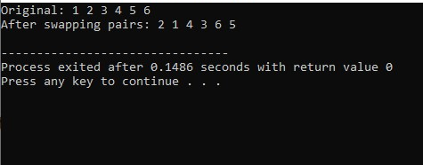

Doubly Linked List
Task 01: Swap desks symmetrically toward center
#include <iostream> // Include input-output stream
#include <string> // Include string class
using namespace std; // Use standard namespace

struct Node { // Node structure for doubly linked list
string name; // Data: desk/person name
Node* next; // Pointer to next node
Node* prev; // Pointer to previous node
}; // End of Node structure

Node* createNode(string name) { // Function to create a new node
Node* newNode = new Node; // Allocate memory for new node
newNode->name = name; // Set node data
newNode->next = nullptr; // Initialize next pointer to null
newNode->prev = nullptr; // Initialize prev pointer to null
return newNode; // Return new node
} // End of createNode

void insertAtEnd(Node*& head, string name) { // Insert node at end
Node* newNode = createNode(name); // Create new node
if (head == nullptr) { // If list is empty
head = newNode; // New node becomes head
return; // Exit function
} // End if
Node* temp = head; // Start from head
while (temp->next != nullptr) { // Traverse to last node
temp = temp->next; // Move to next node
} // End while
temp->next = newNode; // Link old last to new node
newNode->prev = temp; // Link new node back to old last
} // End insertAtEnd

void printForward(Node* head) { // Print list from head to tail
Node* temp = head; // Start from head
while (temp != nullptr) { // Until end of list
cout << temp->name; // Print current name
if (temp->next != nullptr) // If not last node
cout << " <-> "; // Print separator
temp = temp->next; // Move to next node
} // End while
cout << endl; // Print new line
} // End printForward

void swapSymmetric(Node* head) { // Swap first with last, second with second-last, etc.
if (head == nullptr) return; // If list empty, do nothing
Node* tail = head; // Start tail from head
while (tail->next != nullptr) { // Traverse to last node
tail = tail->next; // Move forward
} // End while
Node* left = head; // Left pointer starts at head
Node* right = tail; // Right pointer starts at tail
while (left != right && left->prev != right) { // Stop when pointers meet/cross
string temp = left->name; // Store left data
left->name = right->name; // Copy right data to left
right->name = temp; // Copy stored data to right
left = left->next; // Move left forward
right = right->prev; // Move right backward
} // End while
} // End swapSymmetric

int main() { // Main function
Node* head = nullptr; // Initialize empty list
insertAtEnd(head, "Alice"); // Insert Alice
insertAtEnd(head, "Bob"); // Insert Bob
insertAtEnd(head, "Charlie"); // Insert Charlie
insertAtEnd(head, "Dana"); // Insert Dana
insertAtEnd(head, "Eva"); // Insert Eva
insertAtEnd(head, "Frank"); // Insert Frank
cout << "Original: "; // Print label
printForward(head); // Display original list
swapSymmetric(head); // Perform symmetric swaps
cout << "After swaps: "; // Print label
printForward(head); // Display modified list
return 0; // Return success
}
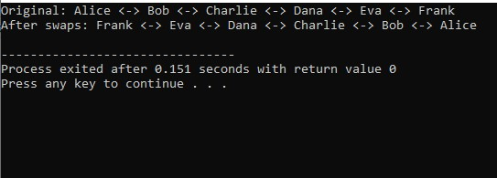
Output:

Task 02: Music player playlist management
#include <iostream> // Include input-output stream
#include <string> // Include string class
using namespace std; // Use standard namespace

struct Song { // Node for a song
string title; // Song title
Song* next; // Pointer to next song
Song* prev; // Pointer to previous song
}; // End Song structure

class Playlist { // Playlist class using doubly linked list
private: // Private members
Song* head; // First song
Song* tail; // Last song
Song* current; // Currently playing song
public: // Public methods
Playlist() { // Constructor
head = nullptr; // Initially empty
tail = nullptr; // Initially empty
current = nullptr; // No current song
} // End constructor

void addSong(string title) { // Add song at end of playlist
Song* newSong = new Song; // Allocate new song node
newSong->title = title; // Set song title
newSong->next = nullptr; // Next is null
newSong->prev = nullptr; // Prev is null
if (head == nullptr) { // If playlist empty
head = newSong; // Head becomes new song
tail = newSong; // Tail becomes new song
current = newSong; // Current becomes new song
} else { // If playlist not empty
tail->next = newSong; // Old tail points to new song
newSong->prev = tail; // New song points back to old tail
tail = newSong; // Update tail
} // End if-else
} // End addSong

void removeSong(string title) { // Remove song by title
Song* temp = head; // Start from head
while (temp != nullptr && temp->title != title) { // Search for title
temp = temp->next; // Move to next song
} // End while
if (temp == nullptr) { // If not found
cout << "Song not found: " << title << endl; // Print message
return; // Exit method
} // End if
if (temp == head) { // If removing head
head = temp->next; // Move head forward
} // End if
if (temp == tail) { // If removing tail
tail = temp->prev; // Move tail backward
} // End if
if (temp->prev != nullptr) { // If node has previous
temp->prev->next = temp->next; // Link previous to next
} // End if
if (temp->next != nullptr) { // If node has next
temp->next->prev = temp->prev; // Link next to previous
} // End if
if (current == temp) { // If removing current song
current = (temp->next != nullptr) ? temp->next : head; // Update current
} // End if
delete temp; // Free memory
} // End removeSong

void displayForward() { // Display playlist from first to last
Song* temp = head; // Start from head
while (temp != nullptr) { // Until end
cout << temp->title; // Print title
if (temp->next != nullptr) cout << " <-> "; // Separator
temp = temp->next; // Move next
} // End while
cout << endl; // New line
} // End displayForward

void displayBackward() { // Display playlist from last to first
Song* temp = tail; // Start from tail
while (temp != nullptr) { // Until beginning
cout << temp->title; // Print title
if (temp->prev != nullptr) cout << " <-> "; // Separator
temp = temp->prev; // Move prev
} // End while
cout << endl; // New line
} // End displayBackward

void playNext() { // Play next song
if (current == nullptr) { // If no current song
current = head; // Set current to head
} else if (current->next != nullptr) { // If next exists
current = current->next; // Move to next
} else { // If at end
current = head; // Wrap around to head
} // End if-else
if (current != nullptr) // If current exists
cout << "Playing: " << current->title << endl; // Display
} // End playNext

void playPrevious() { // Play previous song
if (current == nullptr) { // If no current song
current = tail; // Set current to tail
} else if (current->prev != nullptr) { // If previous exists
current = current->prev; // Move to previous
} else { // If at beginning
current = tail; // Wrap around to tail
} // End if-else
if (current != nullptr) // If current exists
cout << "Playing: " << current->title << endl; // Display
} // End playPrevious
}; // End Playlist class

int main() { // Main function
Playlist pl; // Create playlist object
pl.addSong("Song A"); // Add song A
pl.addSong("Song B"); // Add song B
pl.addSong("Song C"); // Add song C
pl.addSong("Song D"); // Add song D
cout << "Forward: "; // Print label
pl.displayForward(); // Display forward
cout << "Backward: "; // Print label
pl.displayBackward(); // Display backward
pl.playNext(); // Play next
pl.playNext(); // Play next
pl.playPrevious(); // Play previous
pl.removeSong("Song B"); // Remove Song B
cout << "After removal: "; // Print label
pl.displayForward(); // Display forward again
return 0; // Return success
}

Output:
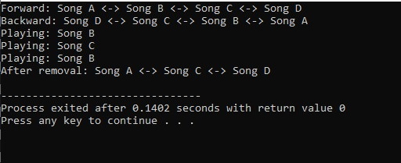

Task 03: Inventory management system
#include <iostream> // Include input-output stream
#include <string> // Include string class
using namespace std; // Use standard namespace

struct Item { // Node for an item
string name; // Item name
string location; // Location inside section
Item* next; // Pointer to next item
Item* prev; // Pointer to previous item
}; // End Item structure

struct Section { // Node for a section
string name; // Section name
Item* itemHead; // Head of items in this section
Section* next; // Pointer to next section
Section* prev; // Pointer to previous section
}; // End Section structure

struct Store { // Node for a store
string name; // Store name
Section* sectionHead; // Head of sections in this store
Store* next; // Pointer to next store
Store* prev; // Pointer to previous store
}; // End Store structure

class Inventory { // Inventory management class
private: // Private members
Store* storeHead; // Head of stores list
public: // Public methods
Inventory() { // Constructor
storeHead = nullptr; // Initially no stores
} // End constructor

Store* findStore(string storeName) { // Find store by name
Store* temp = storeHead; // Start from head
while (temp != nullptr) { // Traverse stores
if (temp->name == storeName) return temp; // Found
temp = temp->next; // Move next
} // End while
return nullptr; // Not found
} // End findStore

Section* findSection(Store* store, string sectionName) { // Find section in store
if (store == nullptr) return nullptr; // Invalid store
Section* temp = store->sectionHead; // Start from section head
while (temp != nullptr) { // Traverse sections
if (temp->name == sectionName) return temp; // Found
temp = temp->next; // Move next
} // End while
return nullptr; // Not found
} // End findSection

void addStore(string storeName) { // Add a new store
Store* newStore = new Store; // Allocate new store
newStore->name = storeName; // Set store name
newStore->sectionHead = nullptr; // No sections yet
newStore->next = nullptr; // Next null
newStore->prev = nullptr; // Prev null
if (storeHead == nullptr) { // If no stores
storeHead = newStore; // New store becomes head
} else { // If stores exist
Store* temp = storeHead; // Start from head
while (temp->next != nullptr) { // Go to last store
temp = temp->next; // Move next
} // End while
temp->next = newStore; // Link last to new store
newStore->prev = temp; // Link new store back
} // End if-else
} // End addStore

void addSection(string storeName, string sectionName) { // Add section to store
Store* store = findStore(storeName); // Find store
if (store == nullptr) { // If store not found
cout << "Store not found\n"; // Print error
return; // Exit
} // End if
Section* newSection = new Section; // Allocate new section
newSection->name = sectionName; // Set section name
newSection->itemHead = nullptr; // No items yet
newSection->next = nullptr; // Next null
newSection->prev = nullptr; // Prev null
if (store->sectionHead == nullptr) { // If no sections
store->sectionHead = newSection; // New section becomes head
} else { // If sections exist
Section* temp = store->sectionHead; // Start from head
while (temp->next != nullptr) { // Go to last section
temp = temp->next; // Move next
} // End while
temp->next = newSection; // Link last to new
newSection->prev = temp; // Link new back
} // End if-else
cout << "Section added.\n"; // Confirmation
} // End addSection

void addItem(string storeName, string sectionName, string itemName, string location) { // Add item
Store* store = findStore(storeName); // Find store
if (store == nullptr) { // If store not found
cout << "Store not found\n"; // Print error
return; // Exit
} // End if
Section* section = findSection(store, sectionName); // Find section
if (section == nullptr) { // If section not found
cout << "Section not found\n"; // Print error
return; // Exit
} // End if
Item* newItem = new Item; // Allocate new item
newItem->name = itemName; // Set item name
newItem->location = location; // Set item location
newItem->next = nullptr; // Next null
newItem->prev = nullptr; // Prev null
if (section->itemHead == nullptr) { // If no items
section->itemHead = newItem; // New item becomes head
} else { // If items exist
Item* temp = section->itemHead; // Start from head
while (temp->next != nullptr) { // Go to last item
temp = temp->next; // Move next
} // End while
temp->next = newItem; // Link last to new item
newItem->prev = temp; // Link new item back
} // End if-else
cout << "Item added.\n"; // Confirmation
} // End addItem

void removeItem(string storeName, string sectionName, string itemName) { // Remove item
Store* store = findStore(storeName); // Find store
if (store == nullptr) { // If store not found
cout << "Store not found\n"; // Print error
return; // Exit
} // End if
Section* section = findSection(store, sectionName); // Find section
if (section == nullptr) { // If section not found
cout << "Section not found\n"; // Print error
return; // Exit
} // End if
Item* temp = section->itemHead; // Start from item head
while (temp != nullptr && temp->name != itemName) { // Search item
temp = temp->next; // Move next
} // End while
if (temp == nullptr) { // If not found
cout << "Item not found\n"; // Print error
return; // Exit
} // End if
if (temp == section->itemHead) { // If removing head item
section->itemHead = temp->next; // Move head forward
} // End if
if (temp->prev != nullptr) { // If has previous
temp->prev->next = temp->next; // Link previous to next
} // End if
if (temp->next != nullptr) { // If has next
temp->next->prev = temp->prev; // Link next to previous
} // End if
delete temp; // Free memory
cout << "Item removed.\n"; // Confirmation
} // End removeItem

void displaySectionItems(string storeName, string sectionName) { // Display items in section
Store* store = findStore(storeName); // Find store
if (store == nullptr) { // If store not found
cout << "Store not found\n"; // Print error
return; // Exit
} // End if
Section* section = findSection(store, sectionName); // Find section
if (section == nullptr) { // If section not found
cout << "Section not found\n"; // Print error
return; // Exit
} // End if
cout << "Items in " << storeName << " / " << sectionName << ":\n"; // Header
Item* temp = section->itemHead; // Start from item head
while (temp != nullptr) { // Traverse items
cout << temp->name << " (Location: " << temp->location << ")\n"; // Print item
temp = temp->next; // Move next
} // End while
} // End displaySectionItems

void displayStoreItems(string storeName) { // Display all items in a store
Store* store = findStore(storeName); // Find store
if (store == nullptr) { // If store not found
cout << "Store not found\n"; // Print error
return; // Exit
} // End if
cout << "Items in store " << storeName << ":\n"; // Header
Section* sec = store->sectionHead; // Start from section head
while (sec != nullptr) { // Traverse sections
cout << "Section: " << sec->name << "\n"; // Print section
Item* item = sec->itemHead; // Start from item head
while (item != nullptr) { // Traverse items
cout << " " << item->name << " (Location: " << item->location << ")\n"; // Print item
item = item->next; // Move next
} // End while
sec = sec->next; // Move next section
} // End while
} // End displayStoreItems
}; // End Inventory class

int main() { // Main function
Inventory inv; // Create inventory object
inv.addStore("StoreA"); // Add store A
inv.addSection("StoreA", "Toys"); // Add Toys section
inv.addItem("StoreA", "Toys", "Car", "A1"); // Add item Car
inv.addItem("StoreA", "Toys", "Doll", "A2"); // Add item Doll
inv.addSection("StoreA", "Grocery"); // Add Grocery section
inv.addItem("StoreA", "Grocery", "Apple", "B1"); // Add item Apple
inv.displaySectionItems("StoreA", "Toys"); // Display Toys items
inv.displayStoreItems("StoreA"); // Display all StoreA items
inv.removeItem("StoreA", "Toys", "Car"); // Remove Car
inv.displaySectionItems("StoreA", "Toys"); // Display Toys again
return 0; // Return success
}
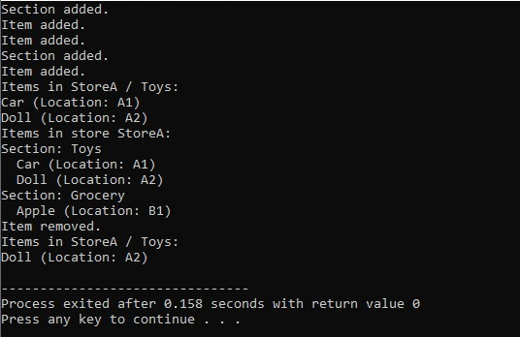
Output:

Task 04: Theater seating pattern
#include <iostream> // Include input-output stream
using namespace std; // Use standard namespace

struct Node { // Node structure for doubly linked list
int data; // Seat number
Node* next; // Pointer to next node
Node* prev; // Pointer to previous node
}; // End Node structure

Node* createNode(int data) { // Create a new node
Node* newNode = new Node; // Allocate memory
newNode->data = data; // Set data
newNode->next = nullptr; // Next null
newNode->prev = nullptr; // Prev null
return newNode; // Return new node
} // End createNode

void insertAtEnd(Node*& head, int data) { // Insert node at end
Node* newNode = createNode(data); // Create new node
if (head == nullptr) { // If list empty
head = newNode; // New node becomes head
return; // Exit
} // End if
Node* temp = head; // Start from head
while (temp->next != nullptr) { // Go to last node
temp = temp->next; // Move next
} // End while
temp->next = newNode; // Link old last to new
newNode->prev = temp; // Link new back to old last
} // End insertAtEnd

void printForward(Node* head) { // Print list forward
Node* temp = head; // Start from head
while (temp != nullptr) { // Until end
cout << temp->data; // Print data
if (temp->next != nullptr) // If not last
cout << " -> "; // Print arrow
temp = temp->next; // Move next
} // End while
cout << " -> NULL" << endl; // Print end
} // End printForward

void alternateSwap(Node* head) { // Swap seats alternately from both ends
if (head == nullptr) return; // If empty, do nothing
int n = 1; // Count nodes, start with 1
Node* tail = head; // Tail pointer
while (tail->next != nullptr) { // Traverse to last node
tail = tail->next; // Move forward
n++; // Increment count
} // End while
if (n < 3) return; // Need at least 3 nodes
Node* left = head->next; // Left starts at second node
Node* right = tail->prev; // Right starts at second-last node
for (int l = 2, r = n - 1; l < r; l += 2, r -= 2) { // Swap pairs
int temp = left->data; // Store left data
left->data = right->data; // Copy right to left
right->data = temp; // Copy temp to right
if (left->next != nullptr && left->next->next != nullptr) // If can move two steps
left = left->next->next; // Move left forward two
else
left = nullptr; // Otherwise null
if (right->prev != nullptr && right->prev->prev != nullptr) // If can move two steps
right = right->prev->prev; // Move right backward two
else
right = nullptr; // Otherwise null
} // End for
} // End alternateSwap

int main() { // Main function
Node* head = nullptr; // Initialize empty list
for (int i = 1; i <= 9; i++) { // Insert 1 to 9
insertAtEnd(head, i); // Insert each number
} // End for
cout << "Original: "; // Print label
printForward(head); // Display original
alternateSwap(head); // Perform alternate swaps
cout << "After calling method: "; // Print label
printForward(head); // Display modified
return 0; // Return success
}
Output:
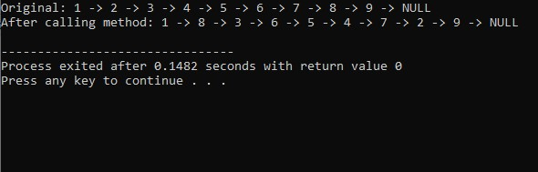

Circular Linked List
- Josephus Problem using circular linked list
#include <iostream> // Include input-output stream library.
using namespace std; // Use standard namespace.

struct Node { // Define a node for circular linked list.
int data; // Store person number.
Node* next; // Pointer to next node.
}; // End of Node structure.

Node* createCircle(int n) { // Function to create circular linked list of 1..n.
if (n <= 0) return nullptr; // Return null if invalid count.
Node* head = new Node; // Allocate first node.
head->data = 1; // Set first person number.
head->next = nullptr; // Initialize next pointer.
Node* last = head; // last points to last created node.
for (int i = 2; i <= n; i++) { // Create persons 2 to n.
Node* newNode = new Node; // Allocate new node.
newNode->data = i; // Set person number.
newNode->next = nullptr; // Initialize next pointer.
last->next = newNode; // Link old last to new node.
last = newNode; // Update last.
} // End for.
last->next = head; // Make list circular.
return head; // Return head of circle.
} // End createCircle.

int josephus(int n, int m) { // Function returns survivor position.
if (n <= 0 || m <= 0) return -1;// Validate inputs.
Node* head = createCircle(n); // Create circle.
Node* curr = head; // curr starts at head.
Node* prev = head; // prev will point to node before curr.
while (prev->next != head) { // Find last node.
prev = prev->next; // Move prev forward.
} // Now prev is last node.
while (curr->next != curr) { // Loop until one node remains.
for (int i = 1; i < m; i++) { // Skip m-1 persons.
prev = curr; // Move prev to curr.
curr = curr->next; // Move curr to next person.
} // End for; curr is Mth person to eliminate.
prev->next = curr->next; // Unlink curr from circle.
if (curr == head) { // If head is being deleted,
head = curr->next; // Update head.
} // End if.
Node* temp = curr; // Store node to delete.
curr = prev->next; // Move curr to next person.
delete temp; // Free memory of eliminated person.
} // End while.
int survivor = curr->data; // Store survivor number.
delete curr; // Delete last node.
return survivor; // Return survivor.
} // End josephus.

int main() { // Program starts here.
int n, m; // n = total persons, m = count.
cout << "Enter number of persons N: "; // Prompt for N.
cin >> n; // Read N.
cout << "Enter count M: "; // Prompt for M.
cin >> m; // Read M.
int result = josephus(n, m); // Call Josephus function.
if (result == -1) { // Check invalid input.
cout << "Invalid input.\n"; // Print error.
} else { // Otherwise,
cout << "Safe position is: " << result << endl; // Print survivor.
} // End if.
return 0; // Return success.
}
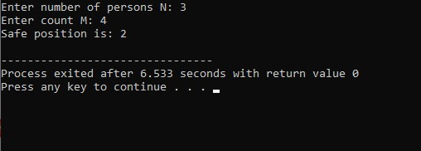
Output:

Task 01: Task Scheduling system using circular linked list
#include <iostream> // For input/output
#include <string> // For string type
using namespace std; // Use standard namespace

// Node for circular linked list
struct Task {
string name; // Task name
int priority; // Task priority
string status; // pending, in-progress, completed
Task* next; // Pointer to next task

Task(string n, int p, string s) { // Constructor
name = n;
priority = p;
status = s;
next = nullptr;
}
};

class TaskList {
private:
Task* head; // Head of circular list
Task* current; // Points to last accessed task for round-robin

public:
TaskList() { // Constructor
head = nullptr;
current = nullptr;
}

// Add a new task at the end
void addTask(string name, int priority, string status) {
Task* newNode = new Task(name, priority, status);
if (head == nullptr) { // If list is empty
head = newNode;
newNode->next = head; // Point to itself
current = head;
} else {
Task* temp = head;
while (temp->next != head) { // Find last node
temp = temp->next;
}
temp->next = newNode;
newNode->next = head;
}
cout << "Task '" << name << "' added.\n";
}

// Remove a task by name
void removeTask(string name) {
if (head == nullptr) {
cout << "List is empty.\n";
return;
}
// If head is to be removed
if (head->name == name) {
if (head->next == head) { // Only one node
delete head;
head = nullptr;
current = nullptr;
} else {
Task* last = head;
while (last->next != head) {
last = last->next;
}
last->next = head->next;
Task* temp = head;
head = head->next;
if (current == temp) current = head;
delete temp;
}
cout << "Task '" << name << "' removed.\n";
return;
}
// Search in rest of the list
Task* prev = head;
Task* curr = head->next;
while (curr != head) {
if (curr->name == name) {
prev->next = curr->next;
if (current == curr) current = curr->next;
delete curr;
cout << "Task '" << name << "' removed.\n";
return;
}
prev = curr;
curr = curr->next;
}
cout << "Task '" << name << "' not found.\n";
}

// Get next pending task in round-robin order
void getNextTask() {
if (head == nullptr) {
cout << "No tasks in the list.\n";
return;
}
if (current == nullptr) current = head;
Task* start = current;
do {
if (current->status == "pending") {
cout << "Next task: " << current->name
<< " (Priority: " << current->priority << ")\n";
current = current->next; // Move for next call
return;
}
current = current->next;
} while (current != start);
cout << "No pending task found.\n";
}

// Display all tasks in a simple format
void displayAll() {
if (head == nullptr) {
cout << "No tasks to display.\n";
return;
}
cout << "\n--- Task List ---\n";
Task* temp = head;
do {
cout << temp->name << " (Priority: " << temp->priority
<< ") - " << temp->status << "\n";
temp = temp->next;
} while (temp != head);
cout << "-----------------\n";
}

// Update status of a task by name
void updateStatus(string name, string newStatus) {
if (head == nullptr) {
cout << "List is empty.\n";
return;
}
Task* temp = head;
do {
if (temp->name == name) {
temp->status = newStatus;
cout << "Status of '" << name << "' updated to "
<< newStatus << ".\n";
return;
}
temp = temp->next;
} while (temp != head);
cout << "Task '" << name << "' not found.\n";
}
};

int main() {
TaskList list;
int choice;
do {
cout << "\n=== Task Scheduler ===\n";
cout << "1. Add Task\n";
cout << "2. Remove Task\n";
cout << "3. Get Next Task\n";
cout << "4. Display All Tasks\n";
cout << "5. Update Task Status\n";
cout << "6. Exit\n";
cout << "Enter choice: ";
cin >> choice;
cin.ignore(); // Clear newline

switch (choice) {
case 1: {
string name, status;
int priority;
cout << "Enter task name: ";
getline(cin, name);
cout << "Enter priority: ";
cin >> priority;
cin.ignore();
cout << "Enter status (pending/in-progress/completed): ";
getline(cin, status);
list.addTask(name, priority, status);
break;
}
case 2: {
string name;
cout << "Enter task name to remove: ";
getline(cin, name);
list.removeTask(name);
break;
}
case 3: {
list.getNextTask();
break;
}
case 4: {
list.displayAll();
break;
}
case 5: {
string name, newStatus;
cout << "Enter task name to update: ";
getline(cin, name);
cout << "Enter new status: ";
getline(cin, newStatus);
list.updateStatus(name, newStatus);
break;
}
case 6: {
cout << "Exiting...\n";
break;
}
default: {
cout << "Invalid choice.\n";
}
}
} while (choice != 6);

return 0;
}
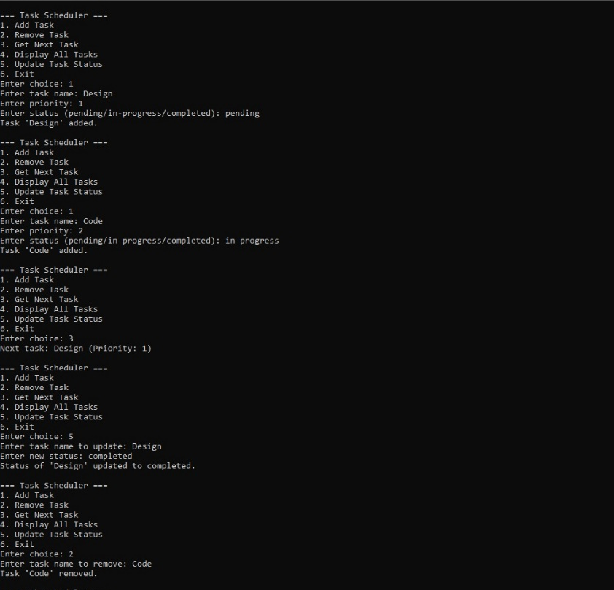
Output:

